Andrew Dykman, Software Development Lifecycles – Assignment 2.1

2.) Step 1.) Requirement Gathering
Step 2.) Quick Design
Step 3.) Building Prototype
Step 4.) Customer Evaluation
Step 5.) Refining Prototype
Step 6.) Engineer Product
2a.) No.

3.)
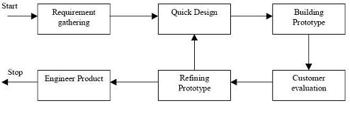
^ Prototyping as Main Technique ^

- The basic idea behind the agile method is to develop a system through repeated cycles (iterative) and in smaller portions at a time (incremental), allowing sotware developers to take advantage of what was learned during development of earlier parts or versions of the system. Learning comes from both the development and use of the system, where possible key steps in the process start with a simple implementation of a subset of the software requirements and iteratively enhance the evolving versions until the full system is implemented. At each iteration, design modifications are made and new functional capabilities are added. As for the object-oriented paradigm, objects can be thought of as wrapping their data within a set of functions designed to ensure that the data are used appropriately, and to assist in that use. The object's methods will typically include checks and safeguards that are specific to the types of data the object contains. An object can also offer simple-to-use, standardized methods for performing particular operations on its data, while concealing the specifics of how those tasks are accomplished. In this way alterations can be made to the internal structure or methods of an object without requiring that the rest of the program be modified. This approach can also be used to offer standardized methods across different types of objects. As an example, several different types of objects might offer print methods. Each type of object might implement that print method in a different way, reflecting the different kinds of data each contains, but all the different print methods might be called in the same standardized manner from elsewhere in the program. These features become especially useful when more than one programmer is contributing code to a project or when the goal is to reuse code between projects. Thus, because of the reuse factor, the iterative / incremental development approach is associated with the object-oriented paradigm.

- Inheritance is one of the most common features of object oriented languages, and has been widely applied to develop large and complex software system. However, designing a suitable inheritance hierarchy, involving redundant inheritance, is a difficult task and easily suffers from name-confliction and repeated inheritance which are error-prone and difficult to test So, the answer is yes.

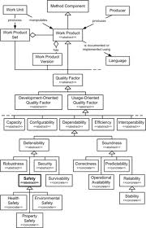

7.) Low coupling is often a sign of a well-structured modular system.

8.) The first consideration when you are writing reusable code is to follow all the guidelines suggested, In other words, write code that uses a consistent naming convention, is formatted properly, and contains useful comments.

10.) Modular programming (also known as top down design and stepwise refinement) is a software design technique that increases the extent to which software is composed of separate, interchangeable components called modules by breaking down program functions into modules, each of which accomplishes one function and contains everything necessary to accomplish this. It is also called conceptually, modules represent a seperation of concerns, and improve maintainability by enforcing logical boundaries between components. Modules are typically incorporated into the program through interfaces. Module interface expresses the elements that are provided and required by the module. The elements defined in the interface are detectable by other modules. The implementation contains the working code that corresponds to the elements declared in the interface.

